Automating the Bathrooms in the North Academic Center
Ishmam Chowdhury, Aman Kaiyum, William Lin, Axel Batista
The City College of New York
Summary
Will be done after full proposal is complete

Automating the Bathrooms in the North Academic Center

Introduction
While the bathrooms may seem like their own issue, it’s imperative to remember that the bathrooms are part of the experience for a CCNY student. Due to humans having fragile immune systems and recuperative capabilities, merely one bad touch or interaction of some kind with a filthy material or person can cause an individual to become sick for a long period of time comparative to how fast and long their courses last. One bad week, which is the usual timespan a person in the age range from 18 to 30 spends sick, can cause that individual to severely underperform on a test or paper they had for that week. As frequent users of the CCNY bathrooms, I will say right now on the behalf of the male side, that these bathrooms, within their current conditions, are prone to causing rampant disease and bacteria to circulate within the premise of the entire CCNY campus given how many people, and the type of people, that use it on a given day.
Average over a week @ 2:00 P.M. :
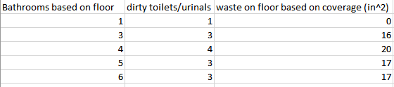

Average over a week @ 10:00 A.M. :
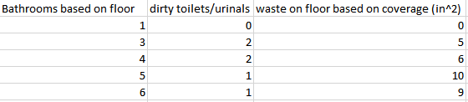

Water Used on Average:
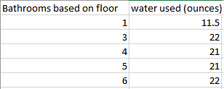
Over the general testing that was conducted, it was found that there was more headway and leniency for the use of automated bathrooms compared to manual ones, in terms of sanitation and energy renewal cost. It would only serve to benefit the entire college, in terms of performance among all bodies of students and staff alike, along with general cost of maintenance, if automated bathrooms were to replace the manual ones set in place, and follow the model of the automated bathroom situated at the first floor. In a collaborative effort, we display the raw data proving that automated bathrooms are better, but as for labor cost and equipment charges, that is something that only the facilities management at ccny can handle. It is up to you to decide on whether to make these changes, and for it to be done within a reasonable time frame that will prove to be long lasting.

Proposed Tasks
More detailed with more research.

Task 3: Hire Contractor
Negotiate labor costs, demands, expectations, and time schedules with the designated contractor.

Task 4: Purchase Appliances
Purchase standard appliances from vendor. Buy them from the same place as the ones from the already automated bathrooms in the NAC, if it’s seen as the best thing to do.

Task 5: Begin Renovations
Begin the renovations going floor by floor. Remove all the toilets, sinks, and soap dispensers and replace them with the automatic counterparts. Take out all of the manual paper towel dispensers and replace them with air hand dryers.
Task 6: Inspection Payment to Contractor
Inspect all the bathrooms to make sure they are to match with criteria set and done within the estimated time frame. Pay the contractor the negotiated price when everything is confirmed to be done as agreed.

Schedule
Will be able to do with more information from tasks. Renovations will be expected to start during the summer when there is generally less traffic on campus; specific timeline will be done when we get email response.

Budget
Rough Estimates based on industry standards:
Appliance | Cost for 1 | Amount per Bathroom | cost per bathroom | Cost for NAC
Sink | $200 | 5 | $1,000 | $40,000
Toilet | $235 | 5 | $1,175 | $47,000
Soap Dispenser | $56 | 5 | $280 | $11,200
Hand Dryer | $400 | 3 | $1,200 | $48,000
Cost of Appliances |  |  |  | $146,200
Labor Cost |  |  |  | $260,000
Total Cost |  |  |  | $406,200

Experience.
Ishmam Chowdhury, second year civil engineering student at The City College of New York.
References

