Date: April 10, 2019
To: Vincent Boudreau, President of CCNY
From: Abir Das, CCNY Student
Mainul Nishan, CUNY Student
Basil Oommen, CCNY Student
Jared Singh, CCNY Student
Subject: Printing Software Proposal: Create an app that students can connect to through
CCNY Wi-fi and print from

Purpose - Our proposal’s purpose is to cater specifically to the students of CCNY. We want to propose the creation of software for printers in the NAC library. This is because students have a lot of trouble printing sometimes, due to the current release station method of printing in the library. There can be a long line of students accumulating around one printer at times, and we want to propose a method or solution to printing in school that is more efficient and accessible to students on campus. We want to call this to attention as well as bring about some sort of research to develop printing software compatible to personal laptops as well as phones, so that students may print from whatever device they use rather than having to sign into their CUNY account every time. This comes into play as well for students who may be late to class, or in the middle of a class that they need a paper printed for. In addition, it is difficult to find free seats with computers during class hours, and students may have to wait just to login and print their papers. Installing this new software could be a grade saver to some people while promoting technological growth in our school in terms of keeping up a good student morale.
Summary - As we all know it is very easy to interact with technology wirelessly. All technology is advancing at a rapid rate where things that were new even two to three years ago are turning old, and here in CCNY we have printers that lack the wireless capability. This prevents students from accessing them from their own computer platforms. Now you may be asking - what is wireless printing software? As stated on the website, HP (a company that makes printers and computers), a wireless printer or wireless printing software can allow users to print from anywhere they want and they do not have to sit next to it, waiting for the grueling printing process. This is one of the largest benefits brought about by technology, and it can be done through the wireless network that is connected to the user’s device via a printing software and the printer on its own. We can apply this into the NAC library by allowing a professional programmer to develop a software that can connect to the CCNY Wi-Fi network and the printers. After making this software we can allow students to install the app on their phone or in their laptop to be able to connect their devices to the printer and start printing from there. As the software gets developed, we can then start putting restrictions where only the people who represent CCNY can use the software and print from there. If it is planned accordingly, printing should be made easier thanks to a new printing software that makes NAC printing more efficient.

Introduction
It is every CCNY student’s nightmare for the printer to break down right before the due date for an important paper that needs to be submitted. The printers stationed in the TECH Center and library are unstable and don’t have easy to use software. Especially, new students must waste their precious time by figuring out how to print documents, when they could use that time doing something meaningful. The current printing interface is very disorganized and complex, making it difficult for many to understand where their documents are being sent to and if they are being printed. This could prove to be daunting for freshmen or students who have not been there before. Having an app to promote would help those who need to print something fast. Not to mention, it is beneficial to the school to have an app like that to promote. For students who don’t own a laptop, it may be difficult to print out documents using the computers in the library, as some computers are situated far from the printers. Sometimes, it is hard to get an open computer to begin with. We understand the frustration of many of our colleagues and want to propose a workable solution. A new and updated system of printer software should be implemented to ease the tensions of students. The current software in place does not clearly state which printer the document is sent to; it also doesn’t indicate if print jobs were submitted or were completed once they are released. This is not ideal for CCNY students, especially those who are taking a large amount of classes containing heavy workloads, those who need to print their documents quickly and efficiently, like textbooks, essays, homework, and more. An updated printing software could allow students to print remotely and at times convenient to them. We want to decrease the time students spend at the printers, while also increasing the amount of papers being successfully printed. In addition, to boost efficiency we want printing software that allows us to disperse documents to printers that are not busy. As there are more than 10 printers in the TECH Center and NAC library combined, it is both wise and logical to notify students which printers are free to use. All in all, this would create a peaceful and organized environment for students taking advantage of CCNY’s amenities.

Proposed Tasks:
With the president’s and CCNY IT’s approval, we want to add wireless printing from an online platform. For example, we can implement a platform or application that is like google cloud printing. This will allow students to print from their Android and IOS devices. We think that adding a contractor that specializes with Oracle software - which is what CUNY is based off - is the best course of action. We have gathered some research from another CUNY college (Hunter) where we have learned that they use what is called google printing mentioned earlier. Hunter’s process is very simple, where the students would use their CUNY ID to get their documents from the printer as they release their documents from their laptops or phones. As part of the CUNY we should be able to use a similar system here at City College along with the wireless idea which can give the students a highly beneficial experience when they need printing.
TASK 1: Firstly, we needed to learn about the NAC printers and what software they use. This can be the basis of our research as a proposal for the President of CCNY to allow. We started our research when we gathered some information about wireless printing from some companies like HP. Based on our research, we have gathered that Hunter and Baruch both have wireless printer capability where students just log into their printing portal with their university username and passwords then select their platform to print their documents. The reasoning behind this information is to understand which printers have a wireless functionality or software that we can manipulate to print wirelessly. This task will be conducted in a safe and coherent manner to abide by CUNY’s code of conduct. It would take a few weeks of gathering information.

TASK 2: How can the coding process work, and with what resources?
Finding a working way to implement code for the printers as a form of software is essential. What language would we need to use is an important question to research and answer ourselves to make the process clear. Different languages could either prove to be easier or harder to program and use; this would also affect the cost of creating a program due to labor hours. The program must be both easy to use and effective in a wide range of scenarios occurring at CCNY. Once we know what we are dealing with, we are then able to hire someone based on what we need. This task could take up to 4 full weeks to gather more information. IT may not even have all the answers We can use coding software’s like C++ language that is taught at City College classes and allow a software developer who is a master in C++ language to create the app. This will lead up to Task 4.
TASK 3: Receive approval from the CCNY President to successfully change the interface for wireless printing. Once we have approval, the IT desk can go through with our proposed schedule. It may be difficult to create code that can effectively work without errors, so this takes the skill of professional developers (which will be mentioned in the budget for cost). We have allowed many weeks in the schedule to wait for approval/tweak our proposal to have more supporting information and evidence.
Task 4: The CUNY Human Resource department will be responsible in the hiring process of software developers and project managers in order to kick off this project. Theses developers must be experienced with:
- Printing software
- Web design
- UI design
If all goes well, this process should not take too long, and many weeks may be left over to fit into the schedule.
Task 5: Once qualified personnel are hired and begin working on this project, test trial runs could be performed. The tests should run under numerous scenarios and conditions to make sure that there are no bugs or problems in the code to solidify the new printing software. Before it is released to the students at CCNY, the software must be able to work effectively through heavy printing loads with ease. We can first try it out with about 2 -3 printers using multiple devices to make sure our idea is working out properly. That should take no longer than 3 weeks’ time.

Schedule:
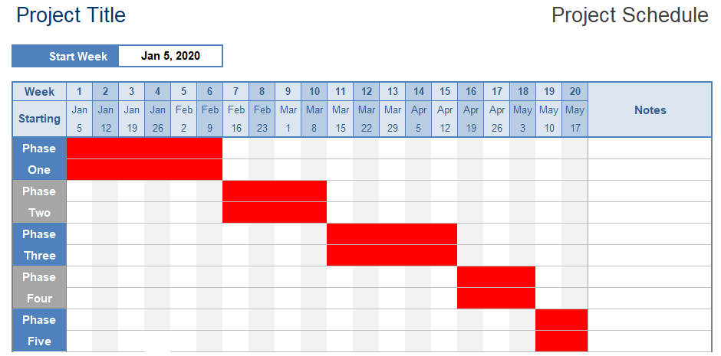
Budget:

Developer | Hours | Yearly Rate | Cost | Time to develop Software
1 | 40 | 90,000 | 81000 | 4-9 Months
2 | 40 | 90,000 | 81000 | 4-9 Months
Project Manager
1 | 40 | 85,000 | 76500 | 4-9 Months

Experience
As CUNY students, we are part of this community and we want to help expand our community while bringing about positive growth.
- Jared Singh, CCNY Grove Freshman student pursuing Computer Science.
- Abir Das, CCNY Grove Freshman student pursuing in Computer Engineering. Currently involved with technical and coding experience in CCNY.
- Basil Oommen, CCNY Grove Freshman majoring in Biomedical Engineering
- Mainul Nishan, Hunter Sophomore who also commutes to CCNY campus for class.

As we pursue degrees in engineering, we think that it is important to turn our work-life passions into something that can help our campus.
References
Baruch Computing and Technology Center (BCTC). (n.d.). Retrieved from https://www.baruch.cuny.edu/bctc/wifiprinting/web-printing-guide.htm
Egerter, J. (2019, February 24). Importance of a Printer. Retrieved from https://www.deanofficesolutions.com/importance-of-a-printer/
How Long Does It Take To Build Custom Software? (2018, November 29). Retrieved from https://soltech.net/how-long-does-it-take-to-build-custom-software/
OneCard-Mobile Printing. (n.d.). Retrieved from http://www.hunter.cuny.edu/it/it-services/repository/files/Mobile Printing.pdf/view?searchterm=
Swolkień, &. (2018, April 26). The cost of software development and tips how to reduce it. Retrieved from https://medium.com/grand-parade/the-cost-of-software-development-and-tips-how-to-reduce-it-60ba44e85948
Wantulok, T. (n.d.). How Important is Technology in Education? Pine Cove's Top 10 Reasons. Retrieved from https://marketing.pinecc.com/blog/the-importance-of-technology-in-education-pine-coves-top-10-reasons
Wireless printing center. (n.d.). Retrieved from https://www8.hp.com/us/en/campaigns/wireless-printing-center/wireless-basics.html

