Proposal to Improve the Effectiveness of ID Checks at entrances of the City College of New York (CCNY) as a Means to Ensure School Safety

Presented to
Ms. Pringle
City College of New York

In Partial Fulfillment of the
Requirements for
Engl 21007

Brandi Lucia Alduk
Nayma Labonna
Adrienne Berrios
Abira Hossain

Purpose
The purpose of our proposal is to request the executive director of the Department of Public Safety, Pat Morena and the president, Dr. Vincent Boudreau to add a digital ID scanner in the buildings of the City College of New York to enhance the security of the school.
Tasks
Task 1. Acquire student’s opinions on the addition of a digital ID scanner and overall CCNY security using a survey
We have already gathered our data by surveying 56 students and recording their answers. In the survey we asked 5 questions about CCNY’s security including their opinion on scanning IDs when entering the buildings. We decided to show the results of two questions which we thought were most significant.
Students opinion on Digitally Scanning IDs when Entering the Building
Figure 1: Percentages of different responses to the question.

Sneaking a non CCNY Student on Campus
Figure 2: Percentages of different responses to the question.
From Figure 1, 46.5% of students are in favor of scanning their IDs when entering the building and from figure 2, 14.5% of students bring outsiders into the buildings of CCNY. From the survey results we can see that non CCNY students enter the buildings which can be risky and majority of the students approve of a digital ID scanner.

Task 3: Choosing a company and products
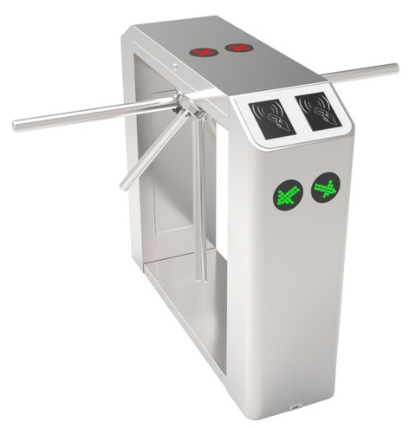
For all the companies that sold the software for scanning the IDs that we researched, we decided on CardExchange Solutions. We specifically chose the “Producer Premium Version” because we felt that it provided the software we were looking for at the best price. According to their website, “With Producer Premium, not only can you use one of our pre-loaded databases, you can also connect to your own MS Access database, MS Excel, and CSV. Every card you create can connect to its own database giving you the ultimate flexibility. A highlight of some of great features include our user and group roles, dropdown picklist fields with fixed text, 2D barcodes, unlimited card templates, UV panel support, filter record lookup, and more. We also include the ability to capture photos, store photos, capture signatures, and other data storage options”. This version is available for $256.

Figure 3: ZKAccess TS2211 Turnstile with Controller and RFID Reader

As for the scanners, we decided on the company ZKaccess and their product “TS2211 Turnstile with Controller and RFID Reader”. ZKaccess makes a variety of tech products and security systems. The security system we are interested in is sold by Surveillance-Video and consists of 2 ID card scanners and 2 turnstiles, as shown in figure 3. It retails for $5,586. We believe that this “2-in-one” system will be much more efficient than just one scanner, which may slow down the amount of students that are able to enter the building.

Task 4. Establish the digital scanners in CCNY
My group and I assume that the ideal time to install the digital ID scanners would be during summer. There will be less students on campus and no difficulties in installing. We think conducting a sample test in the NAC building would be productive. After six months of installing the ID scanners in the NAC building, we can agree if it is efficient and later install in the other buildings on campus.

Task 5: Quality Control
The public safety officers on campus can make sure that the scanning machine and software are working smoothly. If any problems arise, the Office of Information Technology or the Tech Center on campus can be contacted to fix the issue. If the issue still can not be resolved, we can contact the manufacturers of the products.
Schedule
This schedule in Table 1 just shows how long it would take to set up the physical turnstiles, which is one to two hours per turnstile, meaning ideally a team could set up the physical turnstile for one entrance in a day. The software would be set up on the initial day chosen to set up the turnstiles at the main entrance of the North Academic Building, this should also only take a couple hours.
Schedule
Location | Time Frame to Pick From
NAC (Main Entrance) | August 15th, 2019 - August 27th, 2019
NAC (3rd Floor Entrance) | January 21st, 2020 - January 25th, 2020
Marshak (Main Entrance) | August 15th, 2020 - August 27th, 2020
Marshack (Side Entrance) | August 15th, 2020 - August 27th, 2020
Grove (Entrance) | August 15th, 2020 - August 27th, 2020
Table 1: Outline of a Rough Schedule which can be discussed with administration for a specific time.
Budget
The City College of New York seems to be at a deficit and the information provided online is a simple PowerPoint, therefore more documents would be needed in order to correctly budget. The numbers shown will be estimates for how much the entire project should cost.

Budget
Software | $256.00
Turnstiles (100) | $558,600.00
Shipping | $48,179.25
Total | $607,035.25
Table 2: Estimate of Cost of Installation

Experiences
The experience all of us have in common is being engineering students in the Grove School of Engineering. There are four different majors being represented Biomedical, Computers Signs, (blank), and (blank).

